1. Introduction to HIL Testing in Automotive
What is HIL Testing?
Hardware-in-the-Loop (HIL) testing is a validation technique where:
- The real ECU (Electronic Control Unit) hardware is tested
- While the vehicle/environment is simulated in real time
This allows testing before the actual vehicle is available, improving safety and reducing cost.
Why HIL is Important in Automotive?
- Detects software & integration issues early
- Validates ECU behaviour under extreme conditions
- Safer than road testing
- Required by ISO 26262 (Functional Safety)

2. HIL Testing Architecture
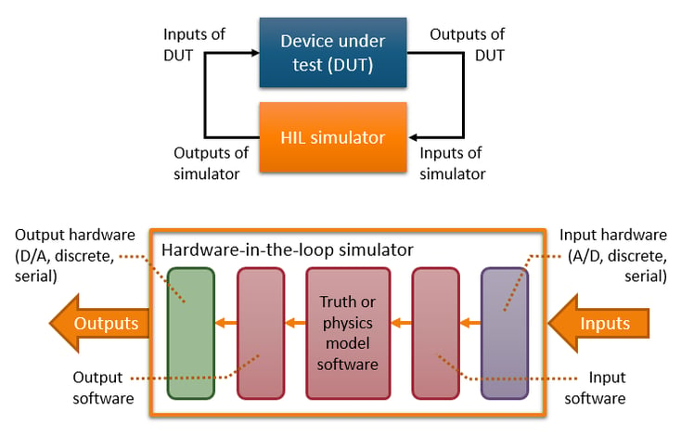
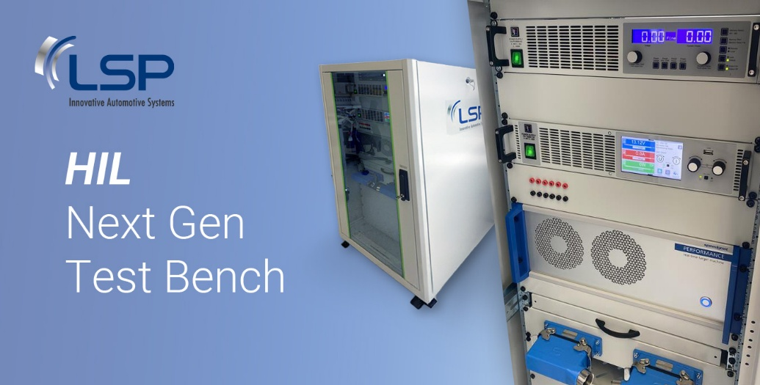
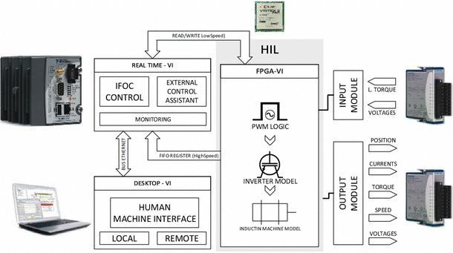
Main Components of a HIL System
- ECU (Hardware Under Test)
- Real-Time Simulator
- Plant Model (Vehicle + Environment)
- I/O Interface (Analog, Digital, CAN, LIN, FlexRay)
- Test Automation & Monitoring Tool

3. Role of MATLAB/Simulink in HIL Testing
Why MATLAB/Simulink?
MathWorks provides MATLAB/Simulink, which is widely used for:
- Model-Based Design (MBD)
- Control algorithm development
- Real-time simulation
- HIL testing
MATLAB vs Simulink
Tool | Purpose
MATLAB | Data analysis, scripting, automation
Simulink | Graphical modelling of systems

4. Automotive System Modelling in Simulink
Typical Models Developed in Simulink
- Engine model
- Brake system (ABS)
- Battery Management System (BMS)
- Electric motor control
- Vehicle dynamics
Model Types
- Plant Model – Simulates real-world physics
- Controller Model – Logic that runs on ECU
5. CAN Bus Communication Basics
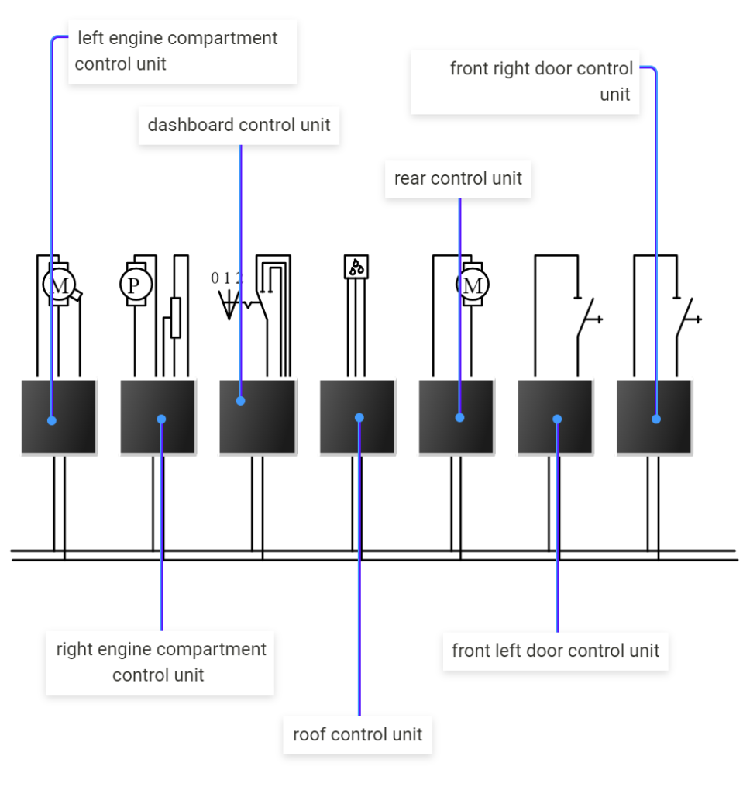
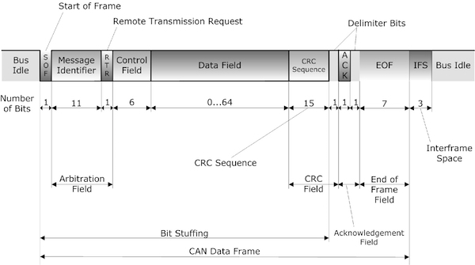
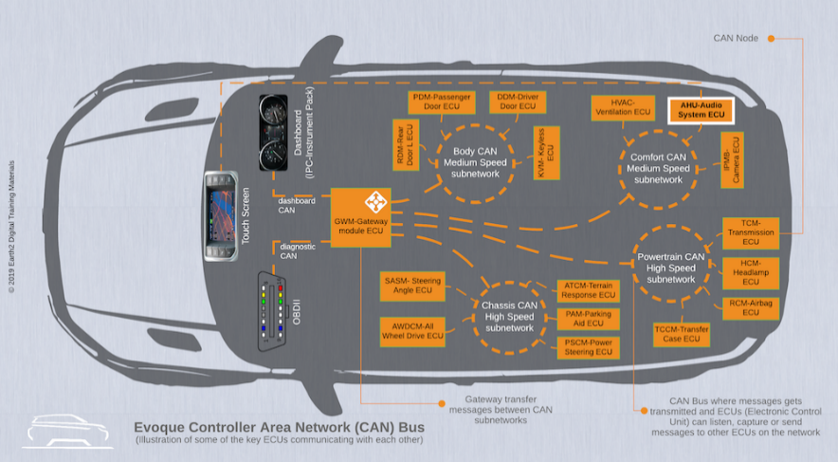
What is CAN?
Controller Area Network (CAN) is a robust serial communication protocol used in vehicles.
CAN Message Structure
- Identifier (ID)
- Data Length Code (DLC)
- Data bytes (0–8)
- CRC
- Acknowledgment
Why CAN is Used in HIL?
- ECU communicates with sensors/actuators via CAN
- Simulated nodes replace real vehicle nodes

6. Simulating CAN Bus in MATLAB/Simulink
Tools Used
- Simulink Vehicle Network Toolbox
- CAN blocks (CAN Transmit / Receive)
- CAN Database (DBC) files
Steps:
- Import DBC file
- Configure CAN channel & baud rate
- Map signals to Simulink blocks
- Send/receive CAN messages in real time

7. HIL Tools – CANoe Integration
What is CANoe?
Vector Informatik provides CANoe, a powerful tool for:
- Network simulation
- ECU diagnostics
- HIL test automation
Role of CANoe in HIL
- Simulates missing ECUs
- Sends test stimuli via CAN
- Logs and analyses bus traffic

8. Developing a HIL Test Setup (Step-by-Step)
Step 1: Define Test Objectives
Example:
- Verify brake ECU response
- Validate fault handling
- Check CAN signal timing
Step 2: Develop Plant Model in Simulink
- Vehicle dynamics
- Sensor models
- Environmental effects
Step 3: Configure Real-Time Execution
- Fixed-step solver
- Real-time compatible blocks
- Sample time matching ECU
Step 4: Connect ECU Hardware
- Power supply
- CAN interface
- Analog/Digital I/O
Step 5: Integrate CAN Communication
- CANoe or Simulink CAN blocks
- DBC-based signal mapping

9. HIL Test Scenarios (Examples)
Scenario 1: Normal Operation
- Speed increases
- Brake applied
- Validate CAN signals & outputs
Scenario 2: Sensor Fault
- Speed sensor stuck at 0
- ECU should enter safe mode

Scenario 3: CAN Communication Failure
- Message delay or loss
- Verify ECU fault response
Scenario 4: Boundary Conditions
- Maximum speed
- Extreme temperatures

10. Executing HIL Tests
Execution Methods
- Manual testing
- Automated test scripts (MATLAB / CANoe CAPL)
- Regression testing
During Execution:
- Monitor CAN signals
- Check ECU outputs
- Log data for analysis

11. Analysing HIL Test Results
MATLAB-Based Analysis
- Plot signals (speed, torque, voltage)
- Compare expected vs actual
- Statistical analysis
CANoe Analysis
- Trace window
- Signal graphs
- Error frames
Pass/Fail Criteria
- Timing constraints
- Value thresholds
- Functional behaviour

12. Advantages of MATLAB/Simulink-Based HIL
- Early bug detection
- Reusable models
- Automated testing
- Compliance with automotive standards

13. Real-World Applications
- Engine Control Unit (ECU)
- ABS / ESP systems
- Electric Vehicle controllers
- ADAS systems

14. Interview & Exam Keywords
- Model-Based Design (MBD)
- Plant model
- Real-time simulation
- CAN DBC
- ECU validation
- Closed-loop testing

15. Summary
- MATLAB/Simulink enables complete HIL workflow
- CAN bus simulation is critical for ECU validation
- HIL testing ensures safe, reliable automotive systems
- Tools like CANoe enhance network-level testing

